Homework 2

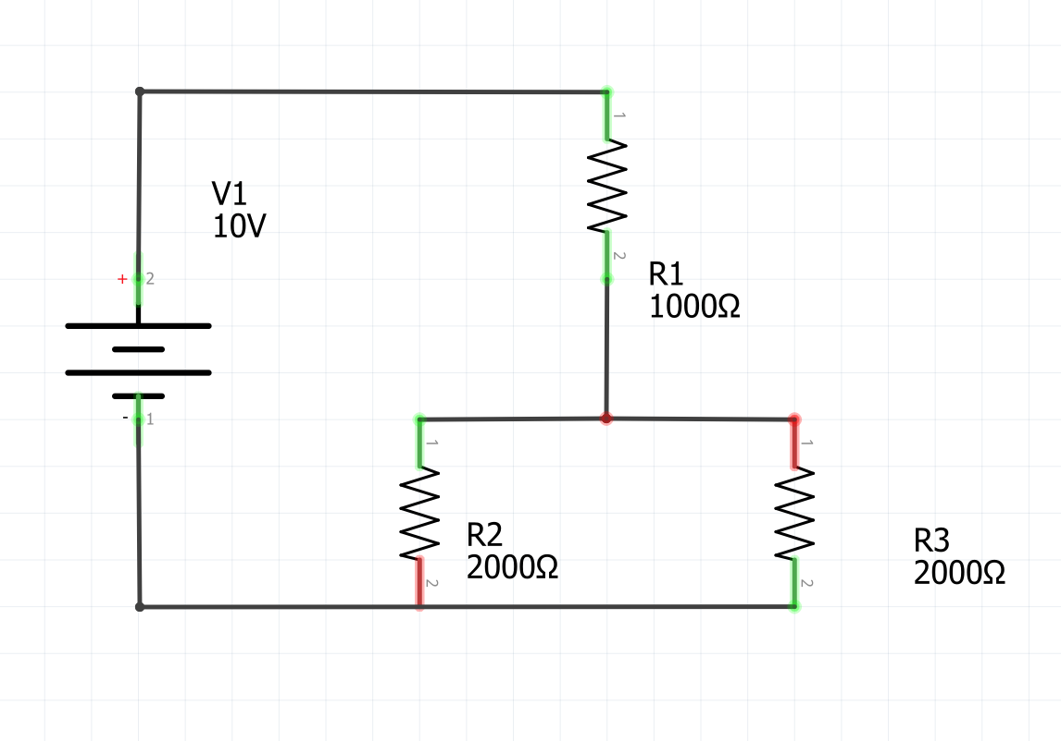

In the figure above find:

1. The voltage across each resistor (V1, V2, V3)
 $\frac{R2R3}{R2+R3}=\frac{2kΩ*2kΩ}{2kΩ+2kΩ}=1kΩ$

 $10V÷2=5v$

 1. R1 = 5V
   2. R2 = 5V
   3. R3 = 5V
2. The current through each resistor (I1, I2, I3)
 $I= \frac{V}{R}= \frac{10V}{2kΩ}=5mA ÷2=2.5mA$

  1. I1 = 5mA
   2. I2 = 2.5mA
   3. I3 = 2.5mA
3. The current supplied by the battery to the circuit (I)
   1. 5mA
4. The power dissipated in each resistor (P1, P2, P3)
$P=VI$

$P1=5V*5mA=25mW$

$P2=5V*2.5mA=12.5mW$

$P2=5V*2.5mA=12.5mW$

5. The power delivered to the circuit by the battery.

$P=VI$

$P1=10V*5mA=50mW$